Clwydian Hills Fell Race 2017
30th Anniversary Race – 22nd October 2017

Race Report
Numbers were down for the race as the unpleasant weather the day before seemed to keep a few people in bed. After a few showers first thing, the skies cleared nicely for the race start and it remained dry all day. I expected a soggy slow race but shows what I know with new course records for male & female being set. The strong wind helped to dry the course and the gusts across the tops kept the runners cool and usually tucked in behind someone else!
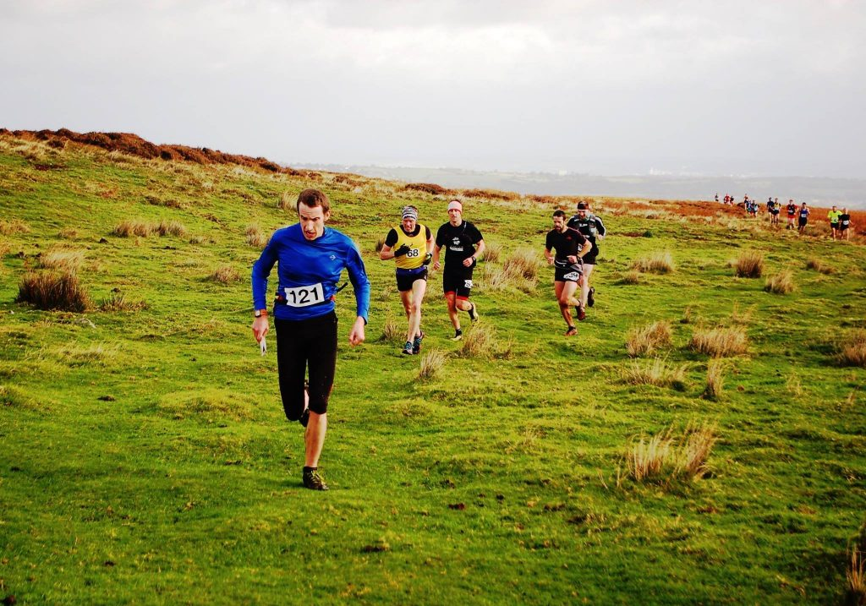
Neil Northrop leads them out
The men's race saw an early lead pack of 4 runners develop of 2015 winner Stephen Skates (Prestatyn), Neil Northop (Dark Peak), Lawerence Eccles (Penny Lane Striders) & Michael Corrales (North Wales Road Runners). Stephen & Neil stretched out a small gap and a two-horsed race developed. Neil led into the bottom of Stony Gully (CP7), over the top of Moel Famau (CP8) and down the north spur (CP9) and looked odds on for the win. Either Stephen was holding something back or his local knowledge paid off down the last descent onto the track where he finished in a new record time of 76m35 (20 seconds ahead of Neil who also broke the old record). Lawrence had pushed out a gap on the chasing pack to finish 3rd in 78m57. Behind the leaders, Michael was battling with the Mercia runners Huw Davies & Ollie Parry just pipping Huw on the line for 4th place with Ollie finishing 6th.
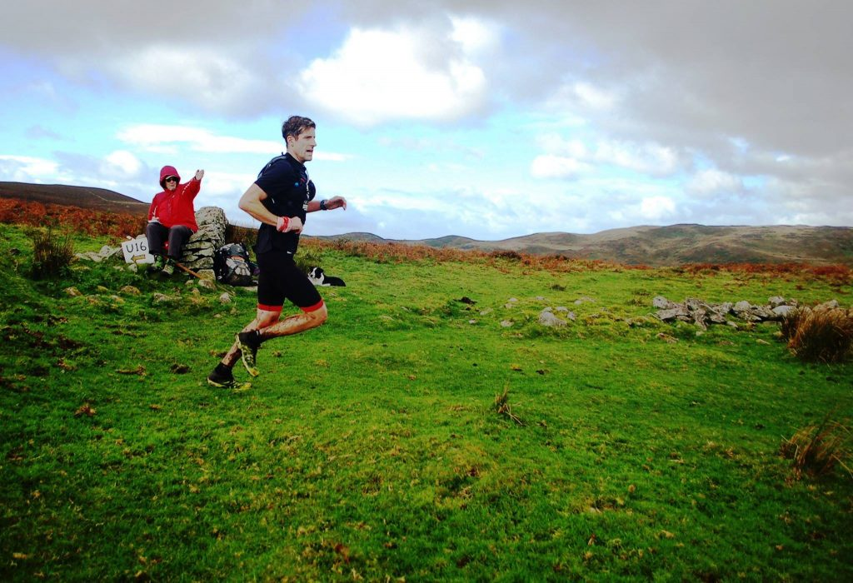
Winner Stephen Skates continues his love of the Clwydian Hills with a new course record
Buckley Runners came home winning the O40, O50 & O70 categories with Jez Brown (7th), Steve Toogood (23rd) & John Morris respectively. Stephen Morran (Bolton AC) won the O60 category. U23 winner was Alex Staniforth (West Cheshire AC).
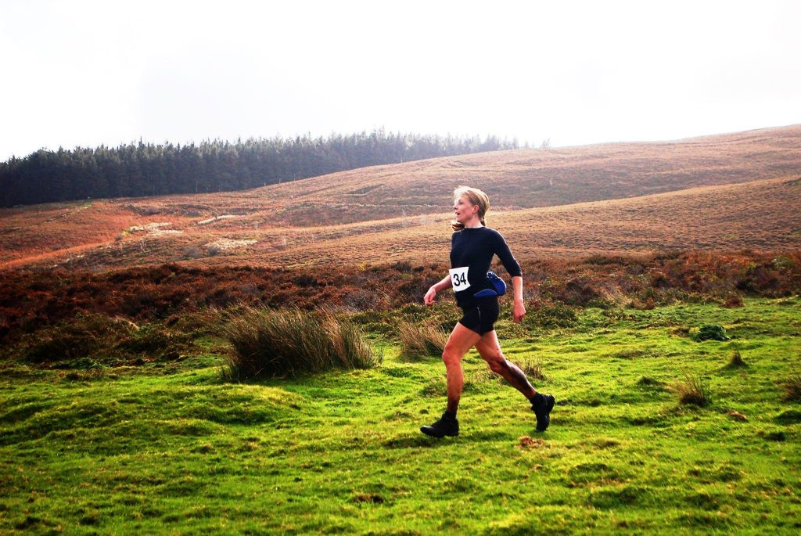
Rachel Chambers on way to victory and new course record
The ladies race was more straightforward with the top order set from the first climb. Rachel Chambers (U/A) outstanding run came home to win in a new record time of 87m31 (12th overall) followed by Zanthe Wray (Dark Peak) and Zoe Barber (Mercia).
Kate Whitfield (Mercia) won the O40 category and Julia Dala (Pensby) took the O50 category.
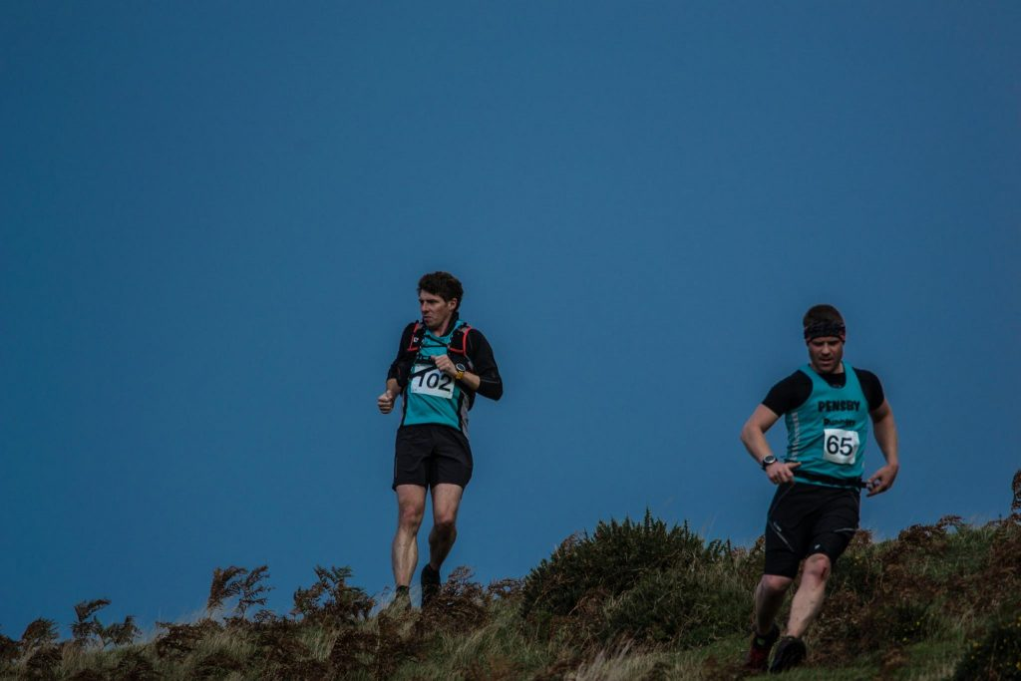
David Green & Richard Matthias helping Pensby to the Petzl Team Trophy
Great showing from the Pensby Runners who managed to get 19 runners to the race which helped them take the Petzl Team Trophy to the Wirral for the first time.
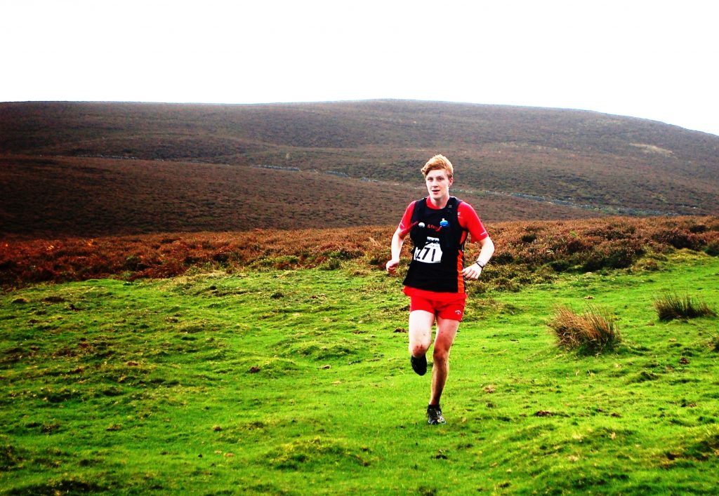
Christopher Larkin U18 Winner
The new U18 & U16 junior races saw a low turnout but this did not stop some excellent performances. Christopher Larkin (Halton & Frodsham) set an excellent time of 49m08 on the M18 course. Lois Lee won the ladies U18 though not content with the new course added a little extra distance to it. Logan Hargreaves-Madhas (Wharfdale Harriers) made the long trip worth it by winning the U16 race though helped in part by 2nd placed Edward Woodhead (West Cheshire AC) going slightly astray on the descent. Eden O'Dea (Wrexham AC) won the ladies W16.
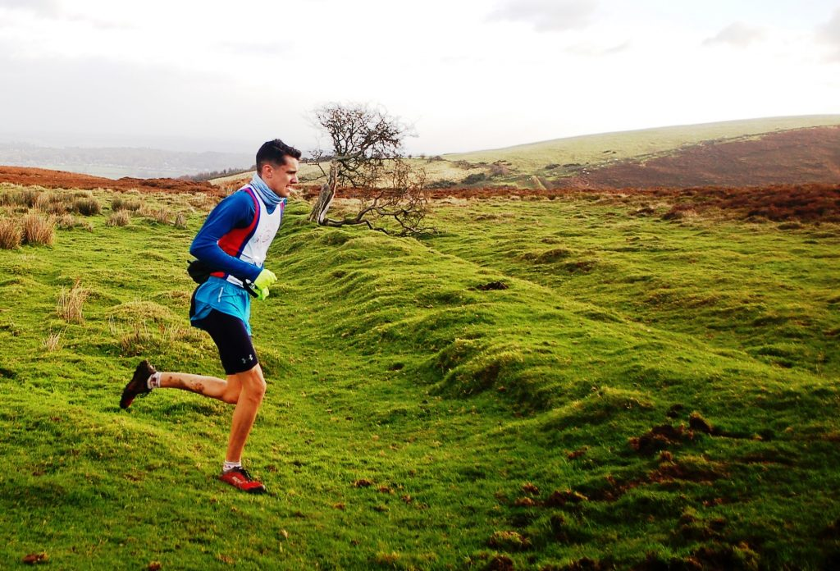
Logan Hargreaves-Madhas M16 Winner
Refreshments, presentations and the obligatory post-race debrief chats were held in Village Hall. A special presentation of a bottle of fizz & flowers were made to the original race organiser John Morris on this the 30th Anniversary of the race.
Special thanks to NEWSAR members and the supporters group for marshalling the race & looking after the runners (and marshals) with homemade soup & cakes. You are all stars and there was a great deal of love from the runners to you folks.
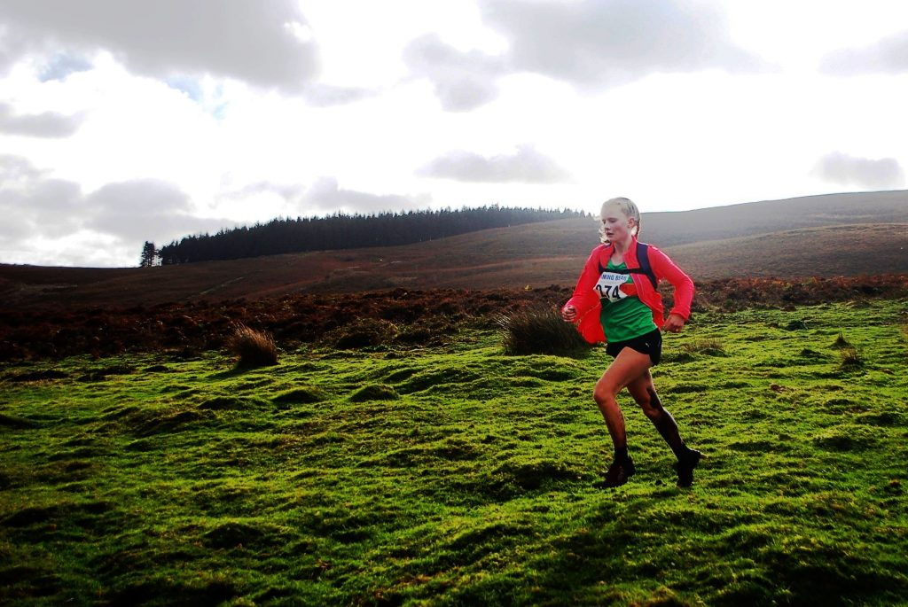
Eden O'Dea W16 Winner
Full results can be found on the website. Click the result tab above or else click here.

